EMBA Newsletter 14th Oct
We pray this newsletter find you well. Please find our latest news and events below. We also ask that you also see the list of the EMBA team updated emails at the bottom of the email.
EMBA Events
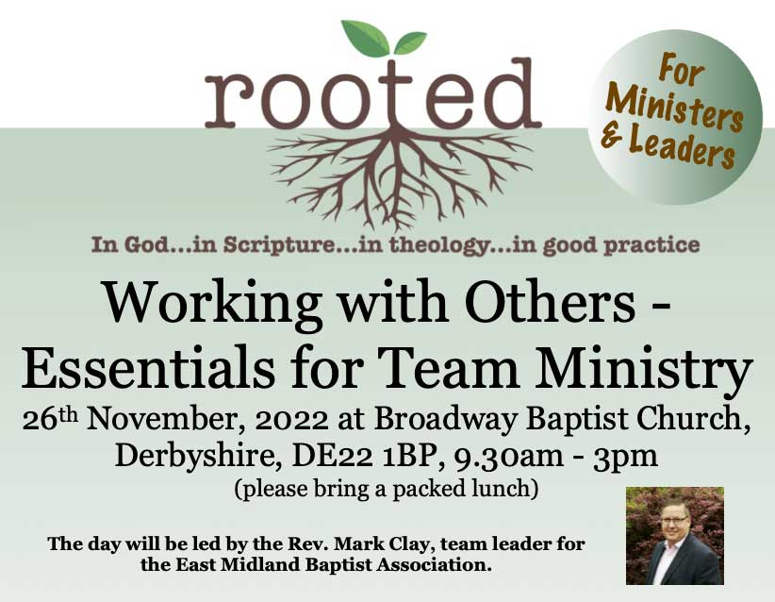
- Rooted for Ministers and Leaders. Saturday 26th November 9:30am to 3pm. Broadway Baptist Church, Broadway, Derby. Working with Others - Essentials for Team Ministry. Come and join us for our next Rooted event where Revd Mark Clay (EMBA RTL) will be focusing on the important area of working with others. In particular, Mark will be helping us to identify some of the real essentials of team ministry in the local church. Book your place here.
- RBMN Advent Gathering. Tuesday 29th November via Zoom. An event open to all EMBA retired ministers and their spouses.Come and join us for our Advent Gathering as we explore together Dane Ortlund's book, 'Surprised by Jesus: Subversive grace in the four Gospels.' The session will include some input and discussion as well as providing an opportunity for fellowship and time to pray for one another. Book your place here.
- 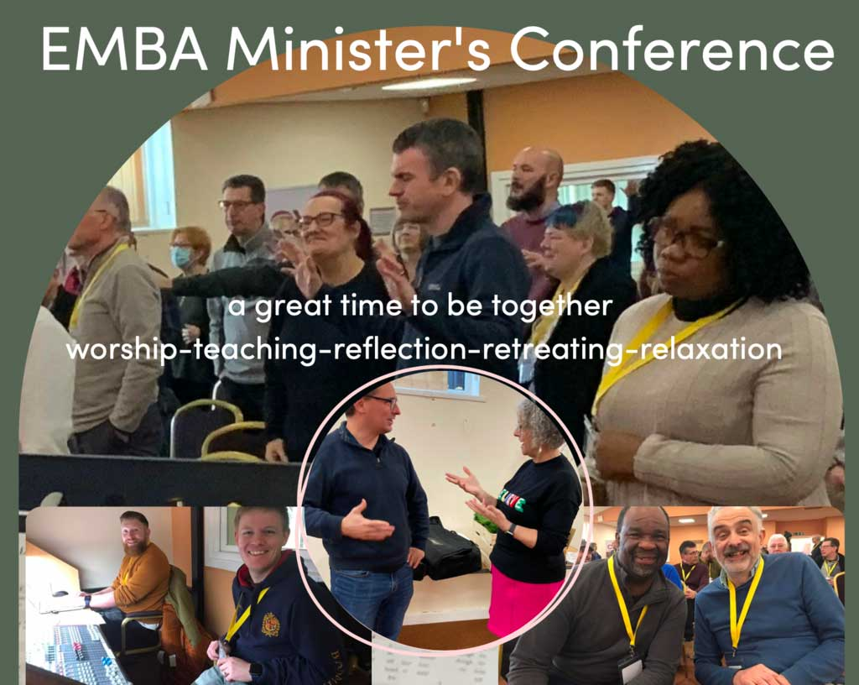
- EMBA Ministers Conference - Wednesday 8th - Friday 10th February 2023. A great time to be together worship - teaching - reflection - retreating - relaxation. Keynote speaker Rev. Dr. Kate Coleman. Book your place here.
Events Around EMBA
- (Re)Introducing Edifi. Northern Baptist College's Online Learning Programme for local churches and leaders. Edifi was founded to offer engaging, relevant, online courses for local Baptist churches and leaders to take up where they are. Courses include teaching from leading practitioners, group learning and interaction and pre and post session studies and activities. Individuals or groups can register to take part. Regular Edifi courses on a range of subjects affecting your church and community will begin this winter so watch this space. Each Edifi course stands alone but participants can follow additional courses to build skills and understanding.
To get a taste of what Edifi has to offer you are invited to two free online events. Find out more and how to book here
- Global Leadership Summit. Tuesday 1st November 9:30am to 4:0pm. The Chapel Centre at Billesdon will be hosting the Global Leadership Summit as a local event on Tuesday 1st November and would like to invite any friends who are interested to join us on that day. For more information and book here.
- Care for the Family Autumn 2022 Event Tour – The Heart of Communication with Rob Parsons in Nottingham on Weds 9th November. Studio 7, Kings Meadow Campus, NG7 2NR, 7.30pm start. Tickets from £5. Book here.
Dates to note for your diaries
- 2023 EMBA AGM - Saturday 24 June 2023. Further information to follow in due course.
If you have any events happening at your church that you'd like us to include on our website, please get in touch.
Other News
- EMBA Safeguarding Training Programme – Autumn 2022. For more information about the safeguarding trainings taking place within EMBA this autumn, please click here. If your church would like to HOST a safeguarding training, we are now looking at dates in 2023.
- We are all feeling the impact of the cost of living crisis and many churches are doing all they can for their communities. One campaign that we have been shared is Warm Welcome, a coalition of Christian organisations with a mission to support organisations to open their doors and provide a warm welcome for those struggling to heat their homes this winter. Find out more here.
- Year of Wellbeing. Renew Wellbeing is partnering with The Big Church Read to invite you to A Year of Wellbeing. Renew Wellbeing is inviting anyone and everyone to join in talking about wellbeing and adopting simple wellbeing habits by reading through the "A-Z of Wellbeing" by Ruth Rice slowly across a whole year and then answering the questions at the end of each chapter either in a group, with a friend or on your own. To find out more visit the Renew Wellbeing website.
- Keyworth Methodist Church with the support of Keyworth Baptist Church are seeking to appoint a creative, imaginative and suitably qualified person to the position of Children and Family Worker based in Keyworth, a large village in rural Nottinghamshire. Closing date is 14th October. More details on the role can be found on the Keyworth Methodist Church website.
- 'Using Digital This Christmas' Webinar. If you missed our recent webinar on using digital in your church comms this upcoming festive season, you can watch it on our youtube channel here.
EMBA Contact Details
Please note that the EMBA now have new email addresses in operation. Please could we ask that the new emails detailed below are used with immediate effect going forward.
Emails sent to our old gmail accounts will be forwarded to our new email addresses whilst we transition but as and from January 2023 we will only be contactable on the emails below:
RTL - Revd Mark Clay mark.clay@embaptists.org.uk
RM - Revd Dr Nick Ashton nick.ashton@embaptists.org.uk
RM - Revd Mike Fegredo mike.fegredo@embaptists.org.uk
Admin Lead - Mrs Becky Nicholls becky.nicholls@embaptists.org.uk
Admin Assistant - Mrs Gill McNab gill.mcnab@embaptists.org.uk
Comms Lead – Mrs Hannah Fleming-Hill hannahfleminghill@embaptists.org.uk
EMBA Bookkeeper – Ms Irene Milburn irene.milburn@embaptists.org.uk
EMBA Treasurer – Mr Andy Smallridge andy.smallridge@embaptists.org.uk
EMBTC Treasurer – Mr Tim Jackson tim.jackson@embaptists.org.uk
EMBA Data Protection Officer – Mr Garry Clewlow garry.clewlow@embaptists.org.uk
EMBA Safeguarding Adviser – Mr Alan Davies alan.davies@embaptists.org.uk
EMBA Safeguarding Adviser – Mrs Helen Parker helen.parker@embaptists.org.uk
EMBA Settlements Administrator – Mrs Julie Lazonby julie.lazonby@embaptists.org.uk
EMBA Home Mission Administrator - Mr Jack Liquorish jack.liquorish@embaptists.org.uk
Ministers' Conference Co-ordinator - Revd Gill Isterling gill.isterling@embaptists.org.uk
Moderator of EMBA Directors – Revd David Harvey david.harvey@embaptists.org.uk
Moderator of EMBTC – Dr Chris Hanning chris.hanning@embaptists.org.uk
EMBTC Trustee with responsibility for Small Building Project Grants - Mr Gary Anderson gary.anderson@embaptists.org.uk
General enquiries hello@embaptists.org.uk
We pray that the oncoming month is a blessing for you and please find the teams contact details here if you need to get in touch with anyone.

