2023 EMBA AGM
Our 2023 EMBA AGM is to be held on Saturday 24 June, 10.00am – 3.00pm at Melton Mowbray BC, Leicestershire.
EMBA Director Nominations Process. At our 2023 AGM we will have TWO vacancies on our EMBA Board of Directors. For further information about the role of an EMBA Director and the nominations process please click on the links below:
Nomination information for churches
Nomination information for churches_2023.pdf
Nomination Form - to be completed by the nominating church. EMBA DIRECTORS_NOMINATION FORM_2023.pdf
Profile Form - to be completed by the nomineeDirector Nominee_profile form_2023.pdf
All nominations (nomination form + profile form) must be returned to Becky Nicholls by no later than Friday 17 March 2023.

- A gracious conversation on human sexuality. In response to the BUGB consultation taking place with churches and ministers early last year regarding marriage and human sexuality, the Association is planning a series of events to help our ministers and church leaders who wish to engage with this consultation to be able to do so in an informed and sensitive manner. To this end we are planning a series of events to help ministers and church leaders facilitate pastorally sensitive conversations in their local churches as appropriate.
  - Thursday 16th March. 9am – 1pm. Facilitating Fruitful Conversation. Improving skills for honest and meaningful discussion. West Bridgford Baptist Church NG2 7NF
  - Tuesday 18th April. 9am – 5pm. Fresh Streams Theology Day. A Gracious conversation on human sexuality. Melton Baptist Church LE13 0FA. The aim of this day will be to create a safe space where healthy, biblical, theological, balanced and gracious conversations can take place around this subject. Please put this date in your diaries!

  - Monday 24th April. 9am – 1pm. Church Conversations. Practical models of how to facilitate gracious discussion. West Bridgford Baptist Church NG2 7NF
- Breaking New Ground. All those who have been baptised into the life of Christ are a called to serve his purposes in the world. For many of us, a significant way in which we do this is by serving our local church, seeking to create a healthy, outward focused community. Such churches are also called to serve God's purposes in the world. If you are a church-based minister, this might be your primary calling.
Some, however, are wired to serve beyond existing structures by starting new ministries and expressions of Christ's kingdom, some of which might emerge into new churches. Such people pioneer new ways of showing the transforming love of Christ, though not all such people would label themselves pioneers. That's what they are though, and we'd love to network such people for mutual encouragement.

- Sue Steer, our EMBA Associate for Pioneering has made a short film about pioneering in the EMBA and we'd love you to show it during a Sunday Service or other gathering of your church. And we'd encourage anyone interested in knowing more to contact Sue by email (suesteer27@gmail.com) or phone (07847 362965)

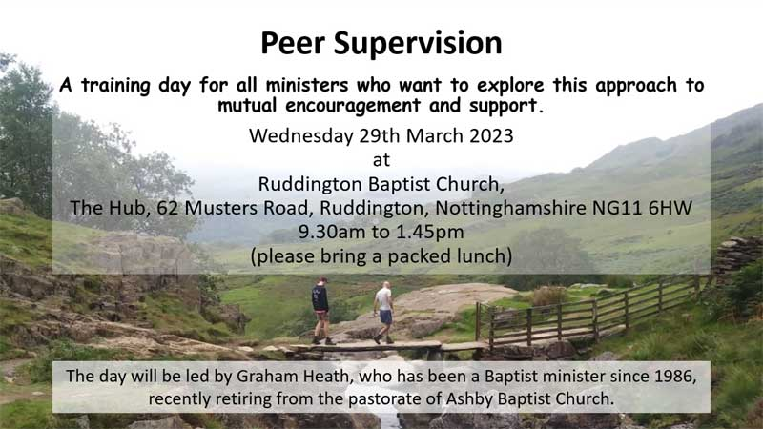
- Peer Supervision. Wednesday 29th March, 9:30am – 1:45pm. A training day for all ministers facilitated by Graham Heath. Peer Supervision offers mutual encouragement and support with another minister, usually at a similar stage of ministry, helping each other reflect and draw benefit from the experiences and challenges we face as followers and ministers of the Lord Jesus; it is an effective way to express 'Habit 3' of 'Continuing Ministerial Development' – and it's free! Book your place here.
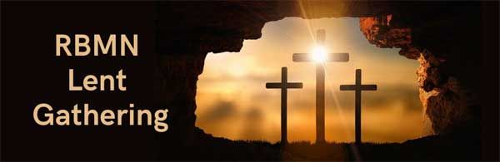
- BMN Lent Gathering with Revd Dr Sally Nelson - Thursday 30 March, 10am – 11.30am via Zoom.This is an EMBA Retired Baptist Ministers' Network gathering open to all EMBA ministers and their spouses. For more information and to book your place, please click here.
Dates to note for your diaries
- Rooted for Ministers and Leaders on 18th November at Broadway Baptist Church, Derby
.
Events Around EMBA
- Hong Kong March Cultural Festival. Hong Kong March (HKM) is a Hong Kong Cultural Festival being held in March in different cities around the UK including Nottingham. For further details on the schedule of Hong Kong March 2023 please look at the Hong Kong March website.
- Baptist Chaplains Day. Monday 17th April 10am on Zoom. The day is free and is for anyone within Baptists Together who acts as a chaplain in any capacity, regardless of accreditation status, hours spent each week in chaplaincy, or sector (or who maybe thinking about becoming a chaplain.) Find out more here.
- May Hunt Ladies Day. Thursday 27th April, 10:30am – 3pm Broadway Baptist Church, Derby. To book your place and for further details, please contact: Llyn Elliott. Phone 07947826729 or email llynelliott22@aol.com or Kathleen Hill Phone 07817422967@btinternet.com
- Satellites Youth Festival. 4th-8th August Bath and West Showground, Somerset. Satellites is a five-day Christian Youth event brought to you by the team at Youthscape, aimed at 12-18 year olds. It's designed to inspire teenagers to live life with God at the centre of their lives for the other 360 days of the year. Last year 60% of those going were from Baptist churches! You can find out more here. Do you have a very small group of 12-18 year olds in your church who would love to go to a big summer festival but you can't find a way to get them there? Do you have a big youth group that you are planning to take to Satellites this Summer? Would you be willing to welcome some young people from a small youth group so they can join in the fun? If either of these is you please get in touch with Sarah Fegredo (Sarah.fegredo@embaptists.org.uk) and she will try and match you up.
If you have any events happening at your church that you'd like us to include on our website, please get in touch.

Other News
- EMBA Safeguarding Training Programme . Please click here for further details of our 2023 training programme. Please do keep checking the website, as new dates will be added as and when they are confirmed.
Other News
- EMBA Safeguarding Training Programme . Please click here for further details of our 2023 training programme. Please do keep checking the website, as new dates will be added as and when they are confirmed.
- Job Vacancies. Loughborough Baptist Church are looking for a part-time administrator, closing date for applications is Monday 13th March. Derbyshire Rural Chaplaincy are looking for a Community Agricultural Chaplain, closing date for applications is Tuesday 21st March. Information on both roles can be found one our Job Vacancies page.
- Edifi Online Course. An online course for those who are preachers, or beginning to preach, or just considering starting out. Learn through input from experienced preachers and those who are journeying into preaching alongside you. Share ideas, practice and experiences and listen to what the Spirit is saying to the churches about communicating the message of Christ in today's new territory and opportunities. The course will take place on Zoom each week on Thursday evenings from 7.30-9pm. Course dates are 27th April, 4th May, 11th May, 18th May, 25th May, 1st June. The cost of the full course and materials is £120. To register or for further information, please contact Edifi Coordinator Margaret Gibbs at edifi@northern.org.uk
- Good News Stories – Do you have something to share? We'd love to know if your church or local group is doing something in your community during the winter months, we'd love to hear of good news stories or just hearing the encouraging things the churches in our Association are do
Please can we ask that if you are about to go on sabbatical, leave or holiday and want to pause the emails you receive from EMBA, please get in touch so that we can make the adjustments. We'd ask that you do not unsubscribe without speaking to us as this can cause problems with how the EMBA holds your information rather than just not receiving emails.
Please find the teams contact details here if you need to get in touch with anyone.

