We ask you to bring the Ukraine into your prayers particularly this week as the war reaches a full year since the outbreak. BMS World Mission are gathering prayers to share with churches in Ukraine. Share your prayer here.
We have uploaded the photos from The EMBA Ministers' Conference onto our Facebook page. Feel free to tag your church or yourself in the photos or if you'd like to use them for your church comms, get in touch with Hannah and we can send a high-res copy to you.
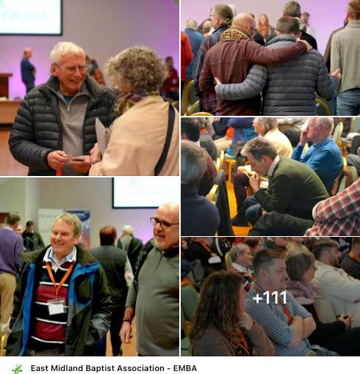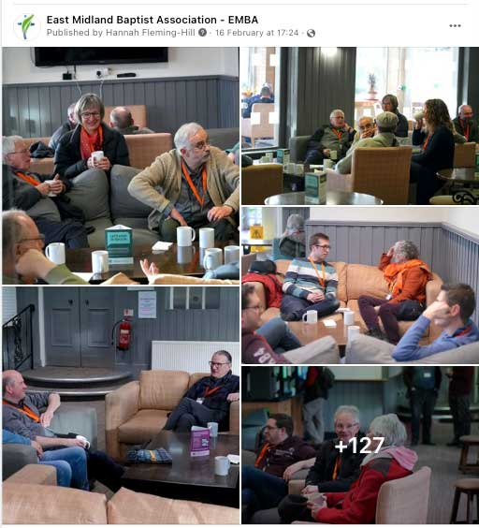
https://www.facebook.com/media/set/?set=a.577002151140113&type=3
Please do make sure to see the full list of updates and events coming up across the Association, please do read through the full newsletter to make sure you don't miss anything.

- EMBA Director Nominations Process. At our 2023 AGM we will have TWO vacancies on our EMBA Board of Directors. For further information about the role of an EMBA Director and the nominations process please click on the links below:
Nomination information for churches
Nomination information for churches_2023.pdf
Nomination Form - to be completed by the nominating church. EMBA DIRECTORS_NOMINATION FORM_2023.pdf
Profile Form - to be completed by the nomineeDirector Nominee_profile form_2023.pdf
All nominations (nomination form + profile form) must be returned to Becky Nicholls by no later than Friday 17 March 2023.

- A gracious conversation on human sexuality. In response to the BUGB consultation taking place with churches and ministers early last year regarding marriage and human sexuality, the Association is planning a series of events to help our ministers and church leaders who wish to engage with this consultation to be able to do so in an informed and sensitive manner. To this end we are planning a series of events to help ministers and church leaders facilitate pastorally sensitive conversations in their local churches as appropriate.
  - Thursday 16th March. 9am – 1pm. Facilitating Fruitful Conversation. Improving skills for honest and meaningful discussion. West Bridgford Baptist Church NG2 7NF
  - Tuesday 18th April. 9am – 5pm. Fresh Streams Theology Day. A Gracious conversation on human sexuality. Melton Baptist Church LE13 0FA. The aim of this day will be to create a safe space where healthy, biblical, theological, balanced and gracious conversations can take place around this subject. Please put this date in your diaries!

  - Monday 24th April. 9am – 1pm. Church Conversations. Practical models of how to facilitate gracious discussion. West Bridgford Baptist Church NG2 7NF
- Breaking New Ground. All those who have been baptised into the life of Christ are a called to serve his purposes in the world. For many of us, a significant way in which we do this is by serving our local church, seeking to create a healthy, outward focused community. Such churches are also called to serve God's purposes in the world. If you are a church-based minister, this might be your primary calling.
Some, however, are wired to serve beyond existing structures by starting new ministries and expressions of Christ's kingdom, some of which might emerge into new churches. Such people pioneer new ways of showing the transforming love of Christ, though not all such people would label themselves pioneers. That's what they are though, and we'd love to network such people for mutual encouragement.

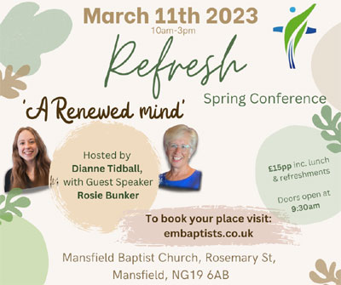

- Refresh Women's Conference. Saturday 11th March 10am – 3pm, Mansfield Baptist Church NG19 6AB. £15 per person (includes lunch and refreshments). Join the Refresh team for their spring conference for a wonderful day of worship, teaching, encouragement and lots of refreshment. Hosted by Revd Dianne Tidball with guest speaker, Rosie Bunker (Grace Church, Nottingham). For more information and to book your place, please click here. Booking deadline: midnight on Wednesday 08 March 2023.

- Sue Steer, our EMBA Associate for Pioneering has made a short film about pioneering in the EMBA and we'd love you to show it during a Sunday Service or other gathering of your church. And we'd encourage anyone interested in knowing more to contact Sue by email (suesteer27@gmail.com) or phone (07847 362965)

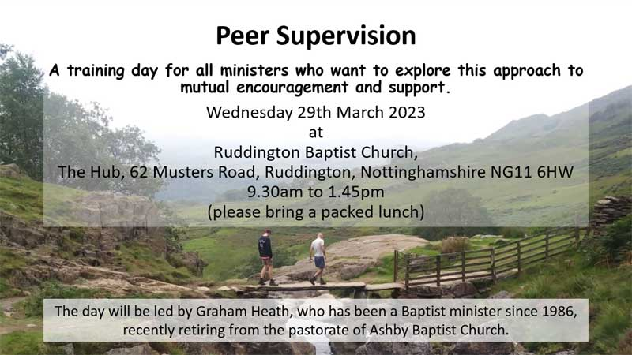
- Peer Supervision. Wednesday 29th March, 9:30am – 1:45pm. A training day for all ministers facilitated by Graham Heath. Peer Supervision offers mutual encouragement and support with another minister, usually at a similar stage of ministry, helping each other reflect and draw benefit from the experiences and challenges we face as followers and ministers of the Lord Jesus; it is an effective way to express 'Habit 3' of 'Continuing Ministerial Development' – and it's free! Book your place here.
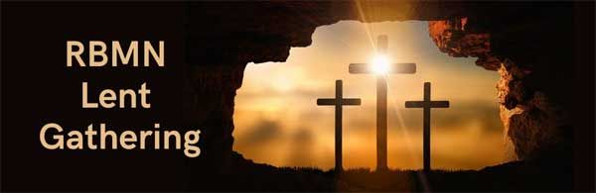
- BMN Lent Gathering with Revd Dr Sally Nelson - Thursday 30 March, 10am – 11.30am via Zoom.This is an EMBA Retired Baptist Ministers' Network gathering open to all EMBA ministers and their spouses. For more information and to book your place, please click here.
Dates to note for your diaries
- Rooted for Ministers and Leaders on 18th November at Broadway Baptist Church, Derby.
If you have any events happening at your church that you'd like us to include on our website, please get in touch.

Other News
- EMBA Safeguarding Training Programme . Please click here for further details of our 2023 training programme. Please do keep checking the website, as new dates will be added as and when they are confirmed.
- Good News Stories – Do you have something to share? We'd love to know if your church or local group is doing something in your community during the winter months, we'd love to hear of good news stories or just hearing the encouraging things the churches in our Association are doing.
- First Friday. A new way to be resourced and supported with communications. The BUGB are running a new monthly Zoom-based gathering, aiming to help anyone involved in communications across Baptists Together. Find out more here.
- We are all feeling the impact of the cost of living crisis and many churches are doing all they can for their communities. One campaign that we have been shared is Warm Welcome, a coalition of Christian organisations with a mission to support organisations to open their doors and provide a warm welcome for those struggling to heat their homes this winter. Find out more here. If you are running a Warm Space this winter, The BUGB have provided some safeguarding guides to ensure that running a warm space is a safe space. Find the guides on the BU website here.
- Operation Agri (OA) is looking for new Trustees, including a new Chair. OA, now in its 62nd year, was established to support the agricultural missionaries of the Baptist Missionary Society (now BMS World Mission) and still maintains close links with the society. For more information on becoming an OA trustee or to have a chat without commitment please contact Nigel Jones, Secretary, on 07889 023 706 or email NigelJones@operationagri.org.uk
- Christian Aid, Changemakers Conference. Saturday 4 March 2023, 10am-4pm, on Zoom. This year's Online Conference will include an exciting range of stories of the Christian Aid work and a first look at this year's Christian Aid Week film. You can watch it Online on your own (even if you can't watch it all, watch what you can). Find out more about the event here.

- DHL at East Midlands Airport are flying aid out to Syria & Turkey to help victims of the terrible earthquake. Having already sent 3 tonnes they are looking to send much more in the light of this ongoing terrible situation. They have scheduled a flight for next week and there will be others on an intermittent basis. Turkish and Syrian authorities have requested the following items:
Heaters
Blankets
Bedding
Pillows
Dry food parcels ie in date tins etc
Hygiene kits
Feminine gygiene products
Clean clothing
Clean baby clothing
sleeping bags
baby formula.
Winter clothing (boots coats hats gloves etc)
If you have any items whether many or few to the main DHL reception at EMA but to make this flight it would need to be there no later than next Thursday 2nd March. If you need any more information, you can contact Roy on 07811040912
Please can we ask that if you are about to go on sabbatical, leave or holiday and want to pause the emails you receive from EMBA, please get in touch so that we can make the adjustments. We'd ask that you do not unsubscribe without speaking to us as this can cause problems with how the EMBA holds your information rather than just not receiving emails.
Please find the teams contact details here if you need to get in touch with anyone.

