

|  |  |
| --- | --- |
|  |  |

|  |
| --- |
| Small text block newsletter.png |

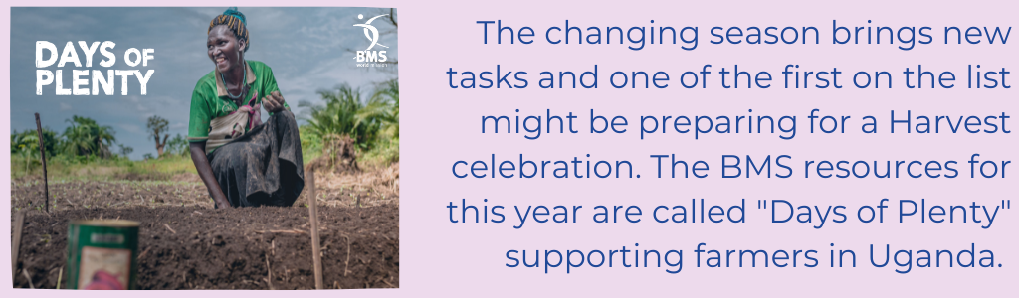

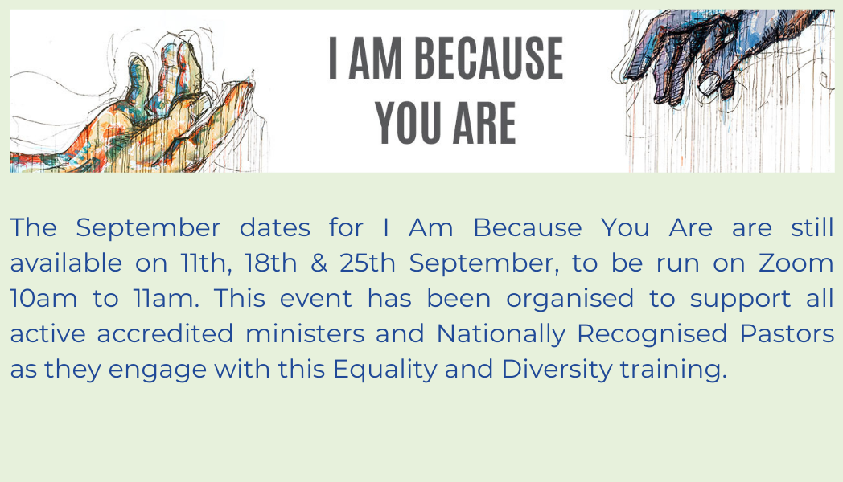

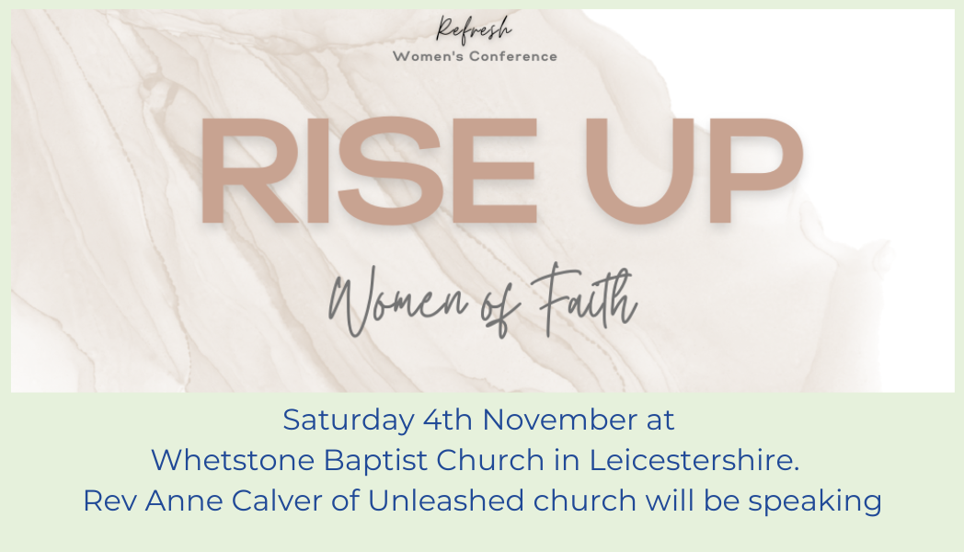

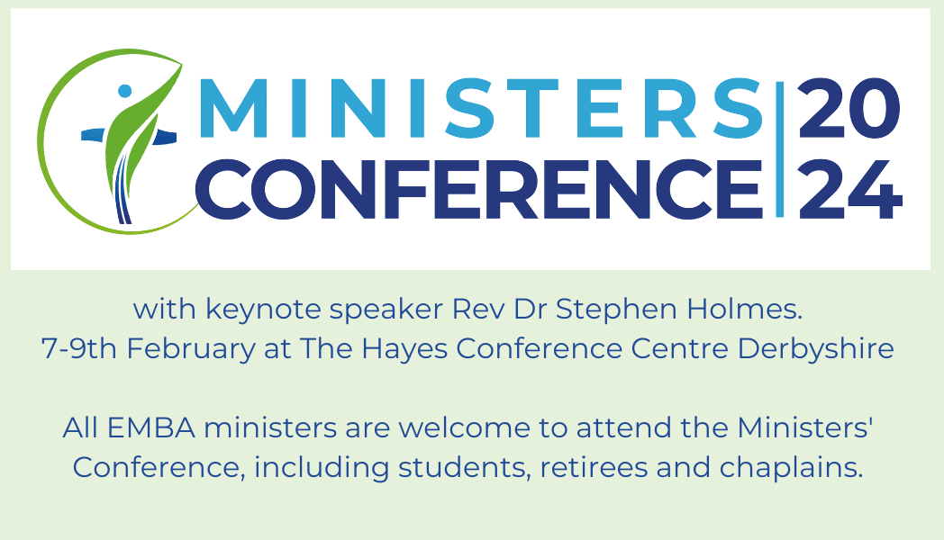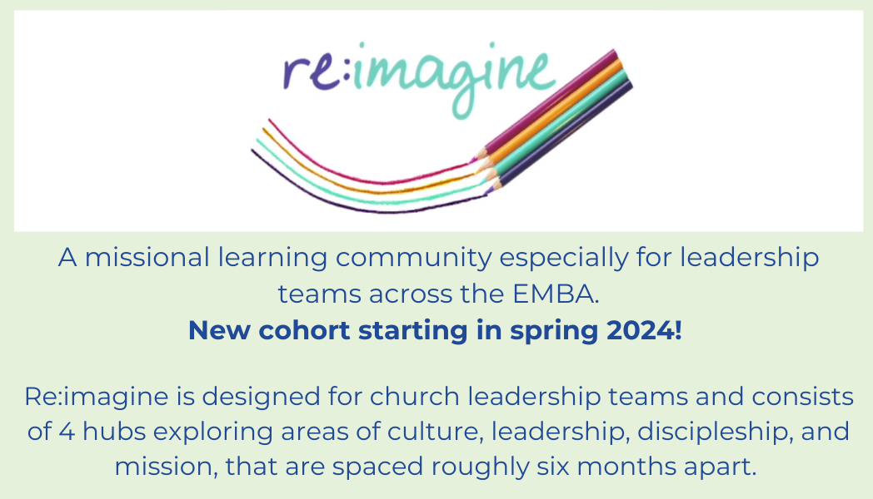  
  
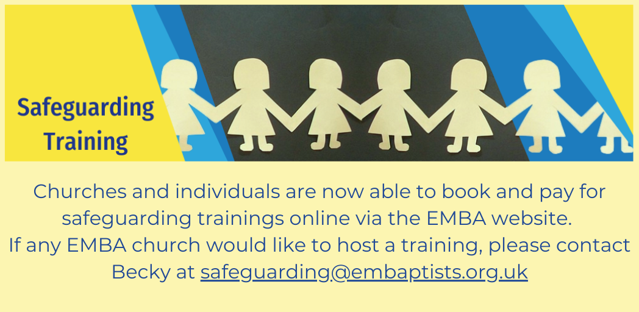

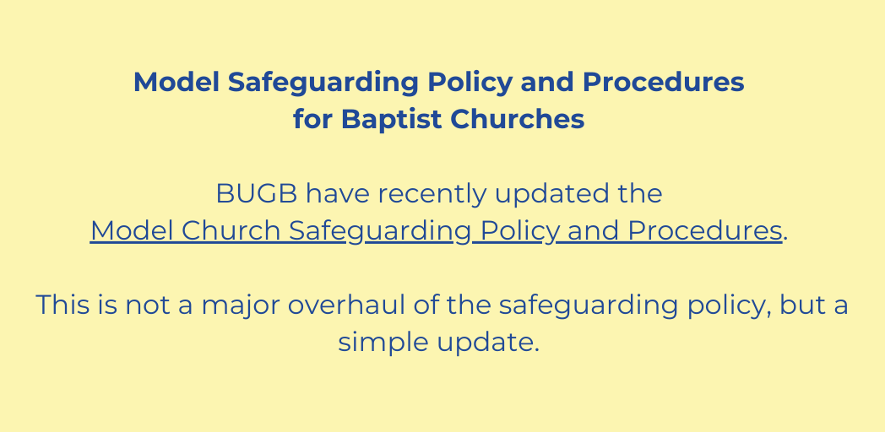



**Fresh Streams Day of Prayer and Fasting**

Thursday 21st September has been set aside for a specific day of prayer and fasting by the Fresh Streams Leadership Team

The EMBA gathering will be at The Well Retford ( Hospital Road, Retford, DN22 7BD ). Further details of the day can be found [**here.**](https://mcusercontent.com/bef4c585e95abc436860eae99/images/5b3e1f76-2b06-b44d-a93e-8a274bff4786.png)

**Soar Valley Gospel Partnership Joint Service**  
Sunday 24th September at 6.30pm.  Hosted by Hathern Baptist Church, The Leys off Anchor Lane, Hathern, LE12 5HX.



Wednesday 18th October at Whitelands College, University of Roehampton.  
Professor Anthony G Reddie will be speaking on 'From Sam Sharpe to Black Lives Matter: The Continued Struggle for Black Agency and Self-determination'  
  
For more information [**CLICK HERE**](https://www.baptist.org.uk/Articles/667711/Sam_Sharpe_Lecture.aspx)

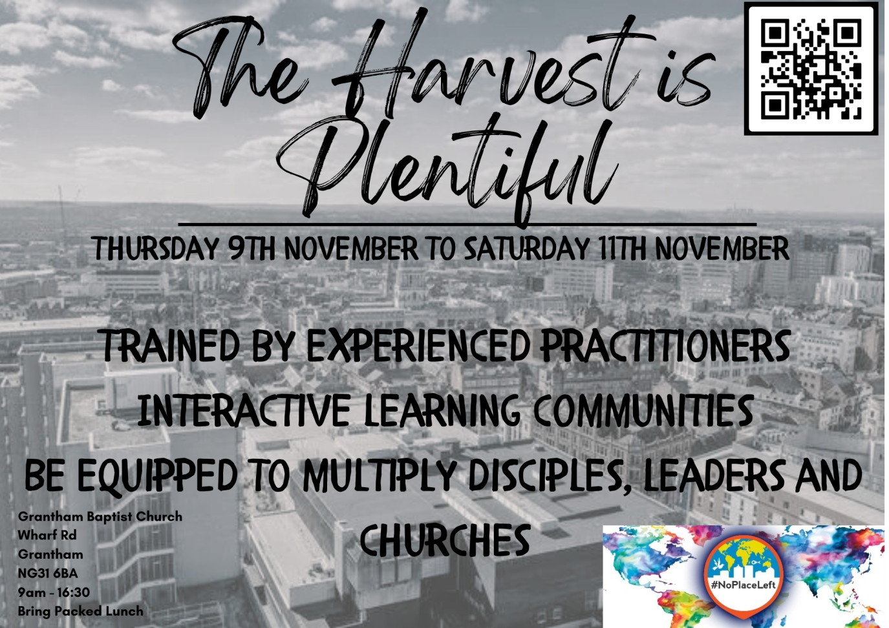

9th-11th November 2023

Grantham Baptist Church is hosting Four Fields Training for those who are "Passionate about seeing a movement of disciples who make disciples? If this is you then come along. Be equipped by the best practitioners in the field"  
For more information and to register [**CLICK HERE**](https://www.eventbrite.com/e/four-fields-training-tickets-690728075267?aff=oddtdtcreator)

**If you have any events happening at your church that you'd like us to include** [**on our website**](https://www.embaptists.co.uk/news-events/)**, please get in touch.**

**Other News**[**Job Vacancies**](https://embaptists.co.uk/news-events/job-vacancies/)

* **Oakham Baptist Church** are recruiting for a Mission and Youth Enabler. Due to the current growth in the life of the church and OBC's role in the community, they are looking to appoint a full time Mission and Youth Enabler.
* For further details on the role as well as any others that we may add and how to apply can be found on the [**EMBA Website.**](https://www.embaptists.co.uk/news-events/job-vacancies/)

Please can we ask that if you are about to go on sabbatical, leave or holiday and want to pause the emails you receive from EMBA, please get in touch so that we can make the adjustments. We'd ask that you do not unsubscribe without speaking to us as this can cause problems with how the EMBA holds your information rather than just not receiving emails.

Please find the [**team's contact details here**](https://embaptists.co.uk/about-us/staff-team/) if you need to get in touch with anyone.

Blessings

EMBA Team