Looking at the various events and activities to include in this first letter of 2024, the theme seems to be prayer. Lots of opportunities are coming up in the next few weeks to pray: for our EMBA churches, for our Baptist movement, and for the unity of God's church in the world.
Starting on January 1st we are inviting you to join in with praying for churches in the Association. On Monday each week we will put the names of a few of our churches in a Facebook post. We'll work alphabetically through our list of 151 churches! You could add the names to your prayers on Sunday morning.
CLICK HERE FOR OUR FACEBOOK PAGE
Baptists Together are inviting us to join together in a day of prayer on 10th January. There will be Live prayer times on social media at 10.30-11.am, shared again at 7.30pm.
CLICK HERE FOR MORE INFORMATION.

The Week of prayer for Christian Unity is 18th-25th January. This year the resources have been prepared by the churches of Burkina Faso.
CLICK HERE TO DOWNLOAD THE RESOURCES AND FIND MORE INFORMATION

Upcoming Events
7-9th February at The Hayes Conference Centre, Derbyshire
All EMBA Ministers are welcome to attend, including students, retirees and chaplains.
Booking closes on 17th January 2024 so make sure you don't miss out.
Farewell to Mike Fegredo  Saturday 16th March 2-4pm West Bridgford Baptist Church  Rev Mike Fegredo, Regional Minister in the EMBA for the last 12 years, is retiring in March. In an informal, cafe style atmosphere we will celebrate with Mike over afternoon tea!  More information and signup will follow soon. | 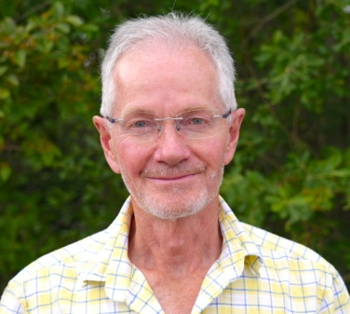

EMBA Gathering
Saturday 29th June 2024 at Wellspring, Whetstone Baptist Church.
Our keynote speaker will be Rev Alex Harris, Regional Minister in the YBA and Director of Baptist Church Planting at St. Hild.
More information will follow but it's another date to put in your diary.
A missional learning community especially for leadership teams across the EMBA
New cohort starting in Spring 2024
re:imagine is designed for church leadership teams and consists of 4 hubs exploring areas of culture, leadership, discipleship and mission that are spaced roughly six months apart

For your diary
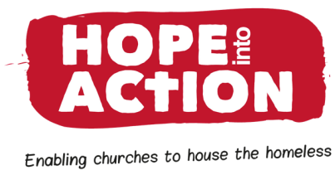 | Sunday 21st January 2024 at 5 pm  Springwell, Whetstone Baptist Church  Dog and Gun Lane LE8 6LJ  Speaker John Kuhrt, CEO of Hope Into Action  Hear how churches can house the homeless. Hear from tenants who have been housed. Be inspired.  Worship, message, updates and prayer.  Followed by refreshments.
Starting 25th January 2024
SEEDBED
Online training to equip leaders to play their part in church planting and mission.
CLICK HERE FOR MORE INFORMATION
Starting February 2024
Exploring Baptist Life
A short course to explore what it means to be part of the radical Baptist movement.
An online course over five sessions to deepen your knowledge of our Baptist tradition.
CLICK HERE FOR MORE INFORMATION
Thursday 18th April 2024
The Hayes Conference Centre, Swanwick
The May Hunt Legacy Trust will be hosting the final Derbyshire Baptist Women's Fellowship Day and invite you to join them. The day will give thanks and celebrate the many years of fellowship and friendship.
Guest speaker Rev Ruth Tiso,
Minister at Peartree Road Baptist Church.
Booking details will be sent out to churches in the New Year.
Baptist President's Visit
Saturday 20th April 10am-1.30pm
Rev Tim Presswood will be visiting the EMBA and is inviting us to join him on a walk and talk around the themes of his presidential year.
Tim believes that Christ's church should reflect Christ's life-giving ministry and the walk will provide opportunity to reflect together on this theme. The walk starts and finishes at West Bridgford Baptist. More details can be found on the EMBA Gatherings page.
CLICK HERE to read more about Tim's theme for the year
Saturday 27th April 2024
Venue to be confirmed
Hearing the Voice of the Child and Young Person in Church
Rev Linda Hopkins will be exploring why we should listen to children and young people, how we can include them in church life and how we can welcome them as part of God's family.
CLICK HERE FOR MORE INFORMATION
Churches and individuals are now able to book and pay for safeguarding trainings online via the EMBA website.
If any EMBA church would like to host a training, please CLICK HERE to go to the Safeguarding training page on the EMBA Website to find out what you need to provide.
If you have any events happening at your church that might be of interest to the wider Association that you'd like us to include on our website, please get in touch with our Comms Lead Sarah Fegredo by email
Job Vacancies
Details about vacancies in the EMBA and more widely can be found on the EMBA WEBSITE VACANCIES PAGE.
Please have a look at your church's "spot" on our website (https://embaptists.org.uk/about-us/churches/) and let us know if any contact info needs updating. It would help people to find you if there was a photo of your building and your website and/or contact email address. We know that the first contact many people have when looking for a church is their website so something that's easy to find helps. Contact SARAH with any updates.
Please can we ask that if you are about to go on sabbatical, leave or holiday and want to pause the emails you receive from EMBA, please get in touch so that we can make the adjustments. We'd ask that you do not unsubscribe without speaking to us as this can cause problems with how the EMBA holds your information rather than just not receiving emails. Please find the team's contact details here if you need to get in touch with anyone.
Blessings
EMBA Team
The EMBA Team
7-9th February at The Hayes Conference Centre, Derbyshire
with Keynote Speaker Rev Dr Stephen Holmes
All EMBA Ministers are welcome to attend, including students, retirees and chaplains.
Booking closes on 17th January 2024 so make sure you don't miss out.
A missional learning community especially for leadership teams across the EMBA
New cohort starting in Spring 2024
re:imagine is designed for church leadership teams and consists of 4 hubs exploring areas of culture, leadership, discipleship and mission that are spaced roughly six months apart

Fresh Streams Conference
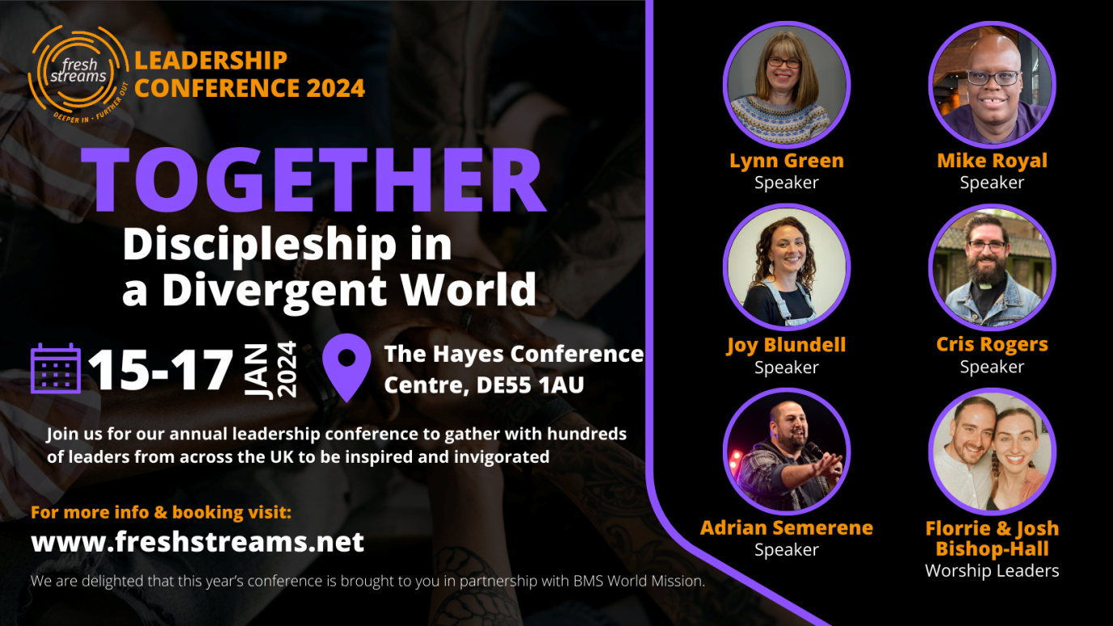
For more information:
CLICK HERE TO GO TO THE FRESH STREAMS WEBSITE

For your diary
Sunday 21st January 2024 at 5 pm
Springwell, Whetstone Baptist Church
Dog and Gun Lane LE8 6LJ
Speaker John Kuhrt, CEO of Hope Into Action
Hear how churches can house the homeless. Hear from tenants who have been housed. Be inspired.
Worship, message, updates and prayer.
Followed by refreshments.
February 2024
Exploring Baptist Life
A short course to explore what it means to be part of the radical Baptist movement.
An online course over five sessions to deepen your knowledge of our Baptist tradition.
CLICK HERE FOR MORE INFORMATION AND TO BOOK
Thursday 18th April 2024
The Hayes Conference Centre, Swanwick
The May Hunt Legacy Trust will be hosting the final Derbyshire Baptist Women's Fellowship Day and invite you to join them. The day will give thanks and celebrate the many years of fellowship and friendship.
Guest speaker Rev Ruth Tiso,
Minister at Peartree Road Baptist Church.
Booking details will be sent out to churches in the New Year.
Saturday 27th April 2024
Venue to be confirmed
Hearing the Voice of the Child and Young Person in Church
Rev Linda Hopkins will be exploring why we should listen to children and young people, how we can include them in church life and how we can welcome them as part of God's family
Churches and individuals are now able to book and pay for safeguarding trainings online via the EMBA website.
If any EMBA church would like to host a training, please CLICK HERE to go to the Safeguarding training page on the EMBA Website to find out what you need to provide.
If you have any events happening at your church that might be of interest to the wider Association that you'd like us to include on our website, please get in touch with our Comms Lead Sarah Fegredo by email
Job Vacancies
Details about vacancies in the EMBA and more widely can be found on the EMBA WEBSITE VACANCIES PAGE.
Please have a look at your church's "spot" on our website (https://embaptists.org.uk/about-us/churches/) and let us know if any contact info needs updating. It would help people to find you if there was a photo of your building and your website and/or contact email address. We know that the first contact many people have when looking for a church is their website so something that's easy to find helps. Contact SARAH with any updates.
Please can we ask that if you are about to go on sabbatical, leave or holiday and want to pause the emails you receive from EMBA, please get in touch so that we can make the adjustments. We'd ask that you do not unsubscribe without speaking to us as this can cause problems with how the EMBA holds your information rather than just not receiving emails. Please find the team's contact details here if you need to get in touch with anyone.
Blessings
EMBA Team

