

|  |  |
| --- | --- |
|  |  |

|  |
| --- |
|  |

To encourage you this Friday, we wanted to share a wonderful story from Tom Bowring and [Oakham Baptist Church](https://oakhambaptist.org.uk) who recently celebrate their 250th birthday.

[**A Party in the Park for Oakham Baptist Church -  Good News Story**](https://embaptists.co.uk/news-events/latest-news/)

To celebrate 250 years of the church, Oakham Baptist held their Big Community Birthday Party on Pentecost Sunday, May 28th in Oakham's central park. With local bands, a free café and plenty of family focussed activities including bungee runs, football shoot outs and even visits throughout the day from Peppa and Chase, the church were hoping the day would be well attended, but little did they expect to see crowds of over 4,000 people.

[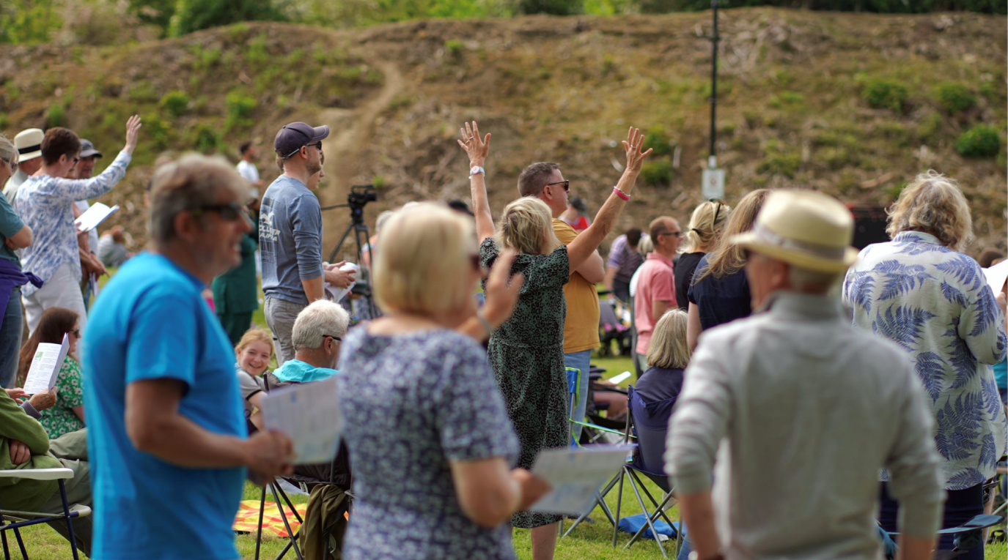](https://embaptists.co.uk/news-events/latest-news/)  
  
"Rutland is the smallest county in the UK with a population of just 40,000, yet to see so many come to celebrate with us is a real indication of the way our community feels about the church and its wider role in society." Says Tom Bowring, minister at OBC. "We launched with a renewed focus on mission and community last year and this event shows just how far the church has come in that time."

Read more about the party on our website [**here**.](https://embaptists.co.uk/news-events/latest-news/)  
  
[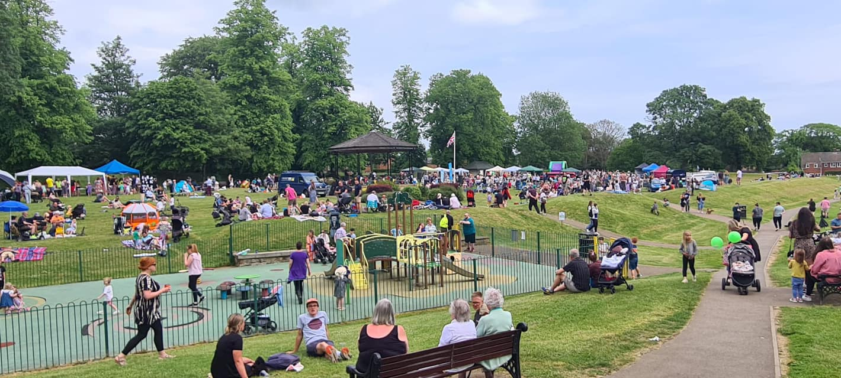](https://embaptists.co.uk/news-events/latest-news/)

If you have any good news stories or things of encouragement to include in our communications, do let us know!

**Serving the Wider Baptist Family**

The Regional Team are always looking for new people to serve in various different ways and so we would love to know about the wealth of gifts, skills and experience held by members of our EMBA members who have some spare capacity and a willingness to share their knowledge and experience to serve our Association.

Are you interested in serving the wider Baptist Family?

Do you have gifts, skills and experience that could benefit the life of the Association?

Do you have some time and energy to invest in a new volunteer role?

If the answer is YES, then we would love to hear from you! Please contact your Regional Minister, contact information can be found [here.](https://embaptists.co.uk/about-us/staff-team/)  
  
  
**Welcome Team Training**   
Helping you take your welcome to a whole new level by:  teaching the Biblical roots of hospitality, exploring key features of Christian hospitality and discovering how to offer a Christlike welcome in your own context. Contact Nick [**here**.](https://www.embaptists.co.uk/how-do-we-help/support-in-ministry/ministerial-development)

[**American Interim Pastors**](http://americaninterimpastors.com)Are you currently: without a pastor, not close to calling anyone and willing to think differently? There is a proven ministry resource that you might consider. Over the past 23 years American Interim Pastors (AIPM), which has partnered with Gateshead international Ministries (GIM) since 2009, has supplied no fewer than 41 interim pastors to serve in 18 British churches around the country and one in Spain, where they typically serve for a period of six months. If you are interested, visit [**the AIPM website**](http://americaninterimpastors.com)for more information.

**Upcoming Events**

[](https://www.embaptists.org.uk/news-events/emba-gatherings/i-am-because-you-are/)  
[**I Am Because You Are.**](https://www.embaptists.co.uk/news-events/emba-gatherings/i-am-because-you-are/)   
The June dates have already started and all must be attend but the September dates are still available on 11th, 18th & 25th September, to be run on Zoom 10am to 11am. This event has been organised to support all active accredited ministers and Nationally Recognised Pastors as they engage with this Equality and Diversity training. Please find further details including the links to the videos required to be watched prior to the meeting, [**here**](https://www.embaptists.co.uk/news-events/emba-gatherings/i-am-because-you-are/). 

[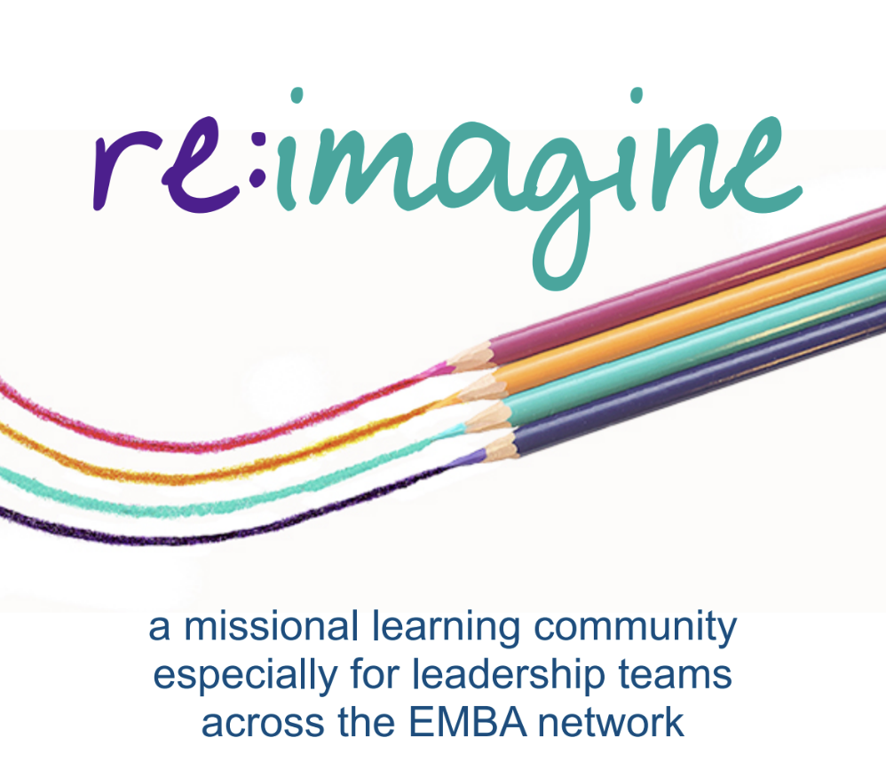](https://embaptists.co.uk/reimagine/)

[**Re:imagine**](https://www.embaptists.co.uk/how-do-we-help/missional-training/reimagine/re-imagine.php)  
New cohort starting in spring 2024! Re:imagine is designed for church leadership teams and consists of 4 hubs exploring areas of culture, leadership, discipleship, and mission, that are space roughly six months apart.   
**Why?** To enable any leadership team in one of our Baptist Churches to build momentum in the transition towards mission becoming the heart of all they are and no longer simply something they do.   
**Who for?** Any church that's feeling stuck. Any church that wants to build momentum towards the future God wants.   
**When?** We gather together for 4 Saturdays spaced roughly 6 months apart, over an 18-month period. We hope this will give time to embed all God is leading us towards.   
If you would be interested in finding out more, please contact your Regional Minister.

**Booking EMBA Safeguarding Trainings** . Churches and individuals are now able to book and pay for safeguarding trainings online via the EMBA website! For more information about trainings coming up in the next few months and to book your place please visit the [**EMBA website**.](https://www.embaptists.co.uk/how-do-we-help/safeguarding/safeguarding-training/training-booking/)

If any EMBA church would like to host a training, please contact Becky at [**safeguarding@embaptists.org.uk**](mailto:safeguarding@embaptists.org.uk)   
If you have a safeguarding concern or would like to seek advice, please contact one of our EMBA Safeguarding Advisers,  you can do so here:   
[**Mr Alan Davies**](mailto:alan.davies@embaptists.org.uk%C2%A0%C2%A0)  
[**Mrs Helen Parker**](mailto:helen.parker@embaptists.org.uk%20%C2%A0)

Their details can also be found [**here**](https://www.embaptists.co.uk/how-do-we-help/safeguarding/safeguarding-advisors/emba-safeguarding-advisors.php).   
  
**Model Safeguarding Policy and Procedures for Baptist Churches**

BUGB have recently updated the [**Model Church Safeguarding Policy and Procedures**](https://www.baptist.org.uk/Articles/512218/Model_Safeguarding_Policy.aspx)**.** This is not a major overhaul of the safeguarding policy, but a simple update. For more information, please visit the safeguarding section of the Baptist Together website [**here**](https://www.baptist.org.uk/Groups/330130/Policies_and_procedures.aspx)**.**

**Dates to note for your diaries**

* Rooted for Ministers and Leaders on 18th November at Broadway Baptist Church, Derby.
* Retired Baptist Ministers Network Advent Gathering on 7th December 10am-12noon via Zoom
* EMBA Ministers' Conference 2024 – Wednesday 7th – Friday 9th February 2024 at The Hayes, Swanwick

Further details on the events to follow.   
  
  
**If you have any events happening at your church that you'd like us to include** [**on our website**](https://www.embaptists.co.uk/news-events/)**, please get in touch.**

**Other News**[**Job Vacancies**](https://embaptists.co.uk/news-events/job-vacancies/)

* **Nottinghamshire Vacancy for a Baptist Representative on SACRE**. SACRE - Standing Advisory Committee for Religious Education, are a statutory body who set and monitor the syllabus for religious education in Nottinghamshire.  The group is made up of representatives from the county council, education and the religious groups represented in Nottinghamshire.
* **Oakham Baptist Church** are recruiting for a Mission and Youth Enabler. Due to the current growth in the life of the church and OBC's role in the community, they are looking to appoint a full time Mission and Youth Enabler.
* **Baptists Together** are recruiting for a Project Analyst. Up to 6 month contract, starting soon – support to the Financial Spending Review Working Group.
* For further details on the roles and how to apply can be found the [**EMBA Website.**](https://www.embaptists.co.uk/news-events/job-vacancies/)

[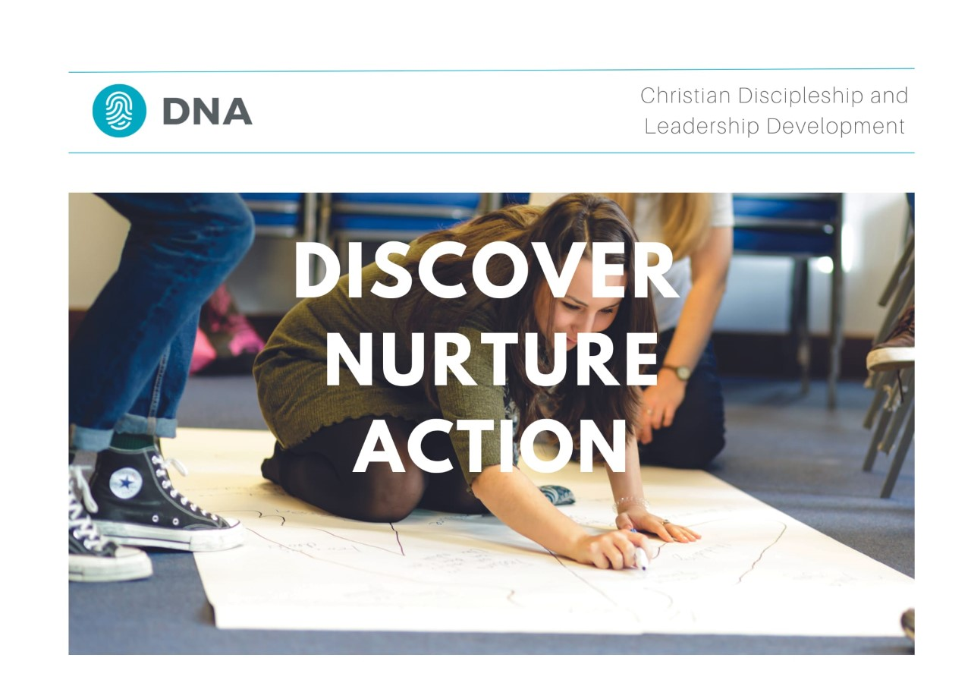](https://dna-uk.org/taster-days/)

* [**DNA – Discover. Nurture. Action.**](https://dna-uk.org/taster-days/) The DNA team have created a number of new online Taster Sessions for people to access if they are interested in finding out more about DNA. These are open both to individuals thinking about DNA for themselves and for church leaders thinking about how DNA may be able to serve their churches.  Find out more [**here**](https://dna-uk.org/taster-days/)
* [**Satellites Youth Festival**](https://www.youthscape.co.uk/satellites). 4th-8th August Bath and West Showground, Somerset. Satellites is a five-day Christian Youth event brought to you by the team at Youthscape, aimed at 12-18 year olds.  It's designed to inspire teenagers to live life with God at the centre of their lives for the other 360 days of the year.  Last year 60% of those going were from Baptist churches! You can find out more [**here**](https://www.youthscape.co.uk/satellites). Do you have a very small group of 12-18 year olds in your church who would love to go to a big summer festival but you can't find a way to get them there? Do you have a big youth group that you are planning to take to Satellites  this Summer?  Would you be willing to welcome some young people from a small youth group so they can join in the fun? If either of these is you please get in touch with Sarah Fegredo ([Sarah.fegredo@embaptists.org.uk](mailto:Sarah.fegredo@embaptists.org.uk)) and she will try and match you up.
* [**Ride and Stride**](https://nottshistoricchurchestrust.org.uk/ridestride/)**.** Help save Notts churches with your weekend walk or bike ride. Join the Ride and Stride event taking place on Saturday 9th September from 10m to 6pm. Find out more [**here**](https://nottshistoricchurchestrust.org.uk/ridestride/%C2%A0)