We are excited to have further details on our AGM & Association Day happening on Saturday 24th June at Melton Mowbray Baptist Church.
You should have received further details including AGM documents in an email earlier this week. However, everything can be found on the EMBA website on the AGM page
For more information about the day and to book your place please click on the link below:
EMBA 2023 AGM & ASSOCIATION DAY (24-Jun-2023) · ChurchSuite Events
Everyone will be welcome to come along on the day but booking would be helpful for us to plan catering etc.
EMBA News
I Am Because You Are. 10am to 11am on 14th, 21st, & 28th June or 11th, 18th & 25th September. On Zoom. This event has been organised to support all active accredited ministers and Nationally Recognised Pastors as they engage with this Equality and Diversity training. Please find further details including the links to the videos required to be watched prior to the meeting, here.
EMBA RBMN Summer Gathering on 13th June 11am – 3pm at West Bridgeford Baptist Church. Come and join us for our Summer Gathering with keynote speaker, Revd Professor Philip McCormack.
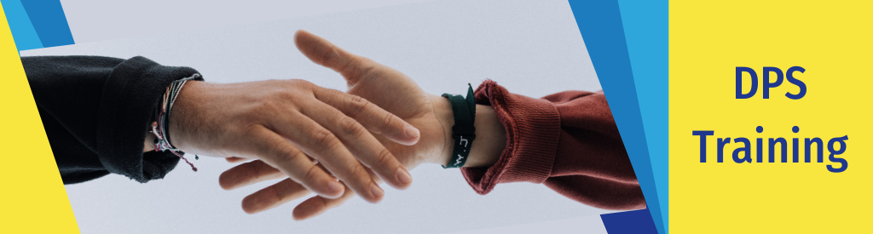
DPS Training Day on Saturday 08 July at 10am – 4pm at West Bridgford Baptist Church, Nottingham.
The National Safeguarding Team are excited to be able to offer safeguarding training specifically for the Designated Person for Safeguarding (DPS) role in EMBA churches. We want to thank you for taking on this important role for your church and have designed this day of training to support you and equip you with confidence to take on the tasks that may be required of you. The training is intended to be interactive and includes opportunity for practical application using scenarios. The day will also allow time to get to know and build relationships with other DPS's in your area. Further information and details of how to book will be available soon.
We highly recommend DPS's to attend this day, but please note this training day is offered to provide additional support for DPS' and does not replace the requirement for DPS's to attend Level 2 and Level 3 training.
Booking EMBA Safeguarding Trainings – Churches and individuals are now able to book and pay for safeguarding trainings online via the EMBA website! For more information about trainings coming up in the next few months and to book your place please visit the EMBA website.
If any EMBA church would like to host a training, please contact Becky at safeguarding@embaptists.org.uk
We have recently updated our EMBA Safeguarding Policy. The revised version can be viewed here

Dates to note for your diaries
Rooted for Ministers and Leaders on 18th November at Broadway Baptist Church, Derby. Further details to follow.
Events Around EMBA
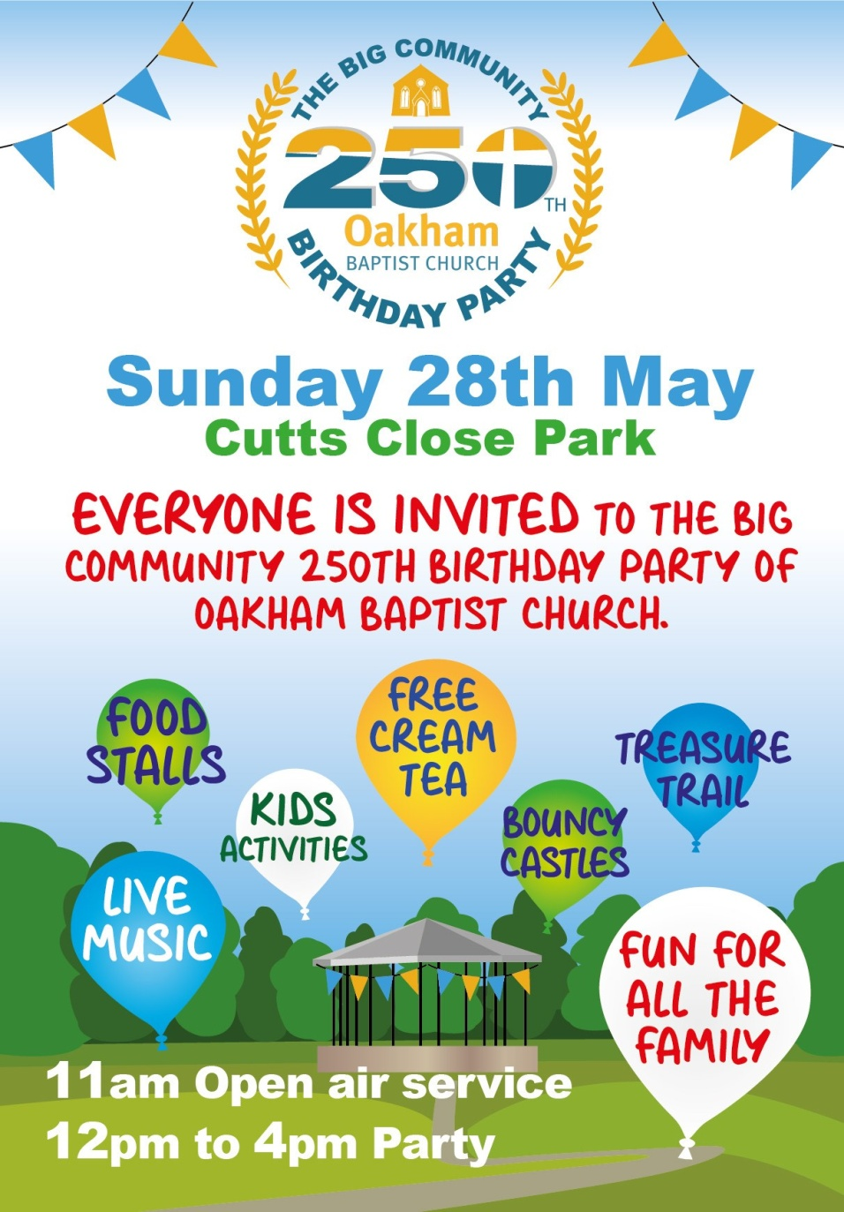
- Oakham Baptist Church 250th Birthday Party. Sunday 28th May, Cutts Close Park, Oakham. Oakham Baptist Church are celebrating their birthday party and inviting everyone to it. With an open air service from 11am then from 12 – 4pm for the party.
If you have any events happening at your church that you'd like us to include on our website, please get in touch.
Other News
Job Vacancies
- Regional Minister: Team Leader for the Eastern Baptist Association. Due to retirement, an exciting opportunity has arisen for a new Regional Minister: Team Leader. This is a full time, paid role, closing date for applications is 29th May. For further details on the role and how to apply visit the EBA website.
- Loughborough Baptist Church is looking to recruit an enthusiastic Children's Worker to lead children's groups within the church and to carry out outreach work. This is a temporary part-time role. Closing date for applications is Monday 12th June 2023. For further detail on the role and how to apply visit the EMBA Vacancies page.
- If you're a Treasurer for your church, did you know that there is a Baptists Together Treasurers Facebook group. It is especially for Treasurers and others involved in finance in Baptists Together churches and organisations to help and share information.

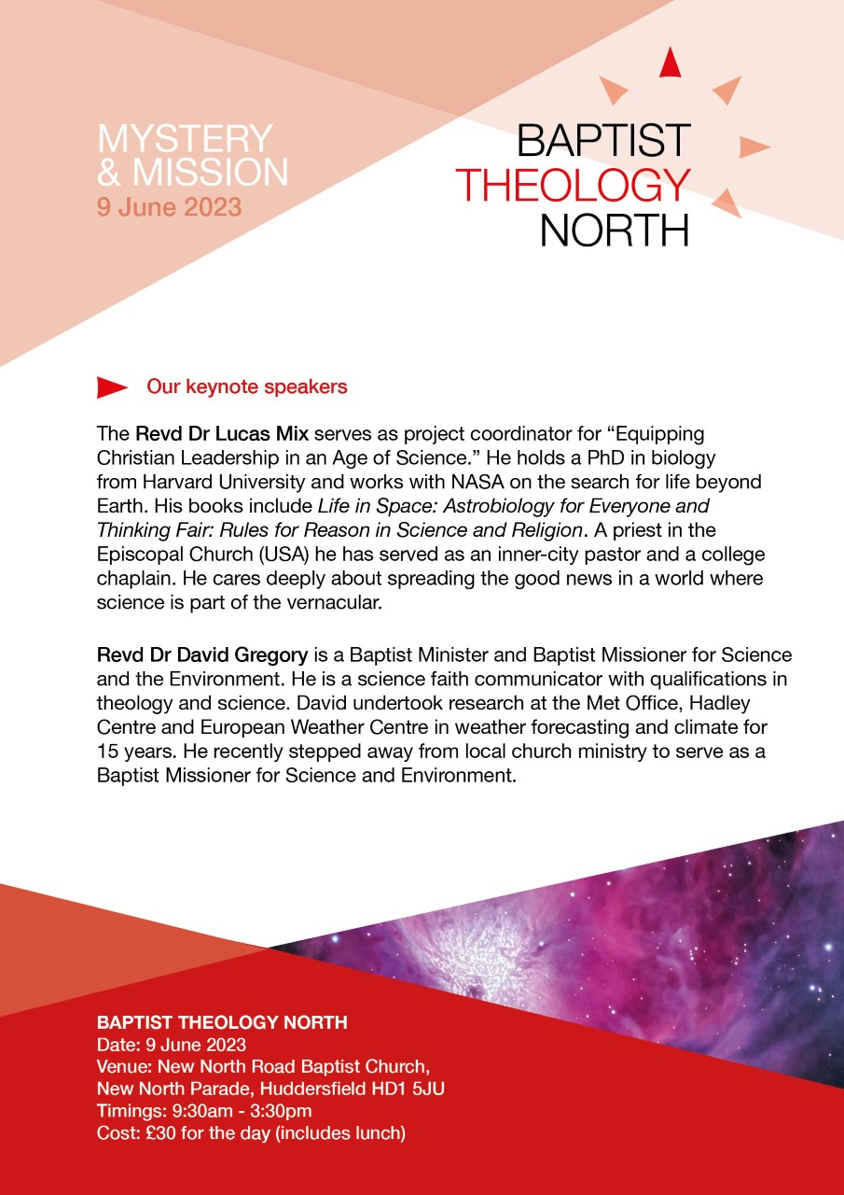
- Baptist Theology North. 9th June at New North Road BC. BTN is an annual one-day theological conversation at which Baptists involved in ministry and mission in the north of England can come together and reflect. If you'd like to book, please get in touch with Revd Dr Sally Nelson
- Edifi Online Quiet Day. Saturday 15th July 10:30am to 3:30pm. Prepare for the summer with a day of reflection with Edifi Online Quiet Day.
The day will be led by Margaret Gibbs and will include:
  - worship
  - teaching input including lessons from Anthony de Mello on recognising and learning to deal with distractions
  - some exercises to practice
  - small group sharing
  - personal reflection time
Find out more and to book your place visit the Eventbrite booking page.
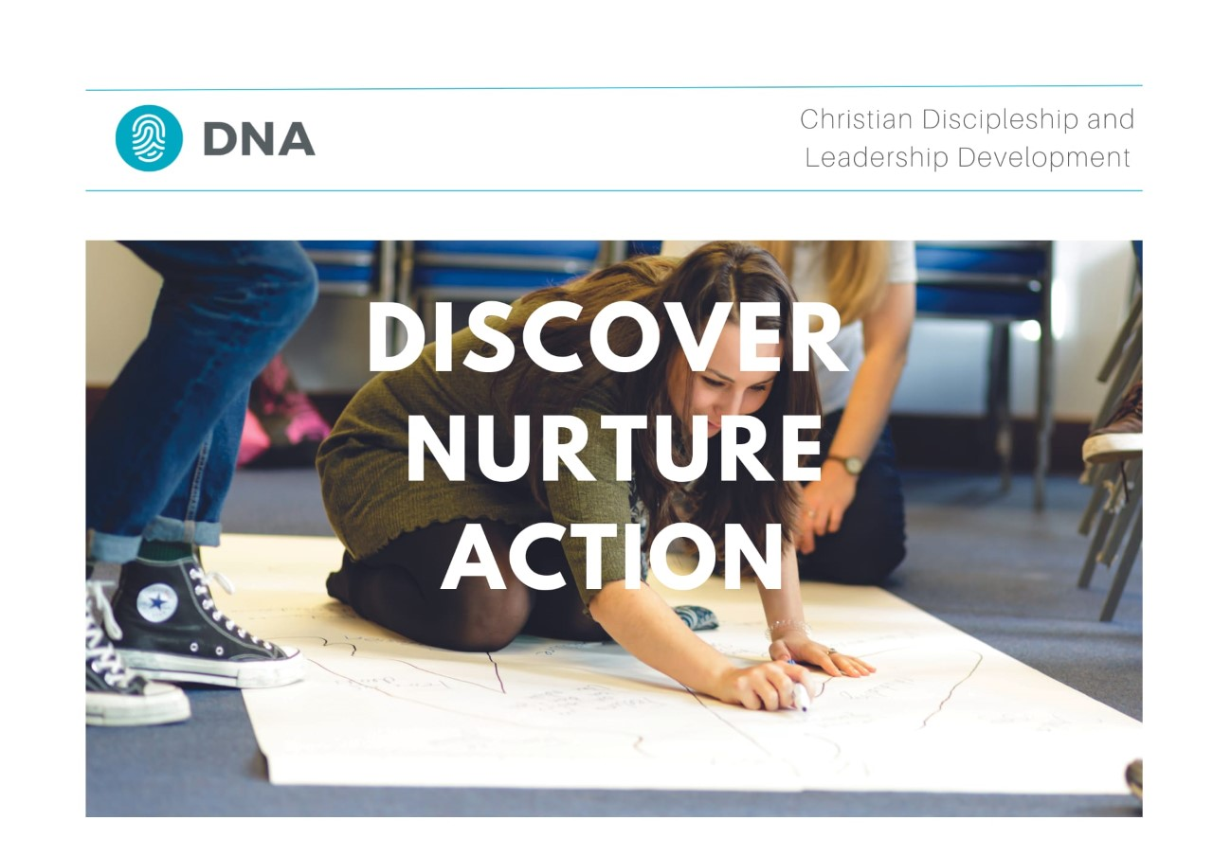
- DNA – Discover. Nurture. Action. The DNA team have created a number of new online Taster Sessions for people to access if they are interested in finding out more about DNA. These are open both to individuals thinking about DNA for themselves and for church leaders thinking about how DNA may be able to serve their churches. Find out more here
- Satellites Youth Festival. 4th-8th August Bath and West Showground, Somerset. Satellites is a five-day Christian Youth event brought to you by the team at Youthscape, aimed at 12-18 year olds. It's designed to inspire teenagers to live life with God at the centre of their lives for the other 360 days of the year. Last year 60% of those going were from Baptist churches! You can find out more here. Do you have a very small group of 12-18 year olds in your church who would love to go to a big summer festival but you can't find a way to get them there? Do you have a big youth group that you are planning to take to Satellites this Summer? Would you be willing to welcome some young people from a small youth group so they can join in the fun? If either of these is you please get in touch with Sarah Fegredo (Sarah.fegredo@embaptists.org.uk) and she will try and match you up.
- Ride and Stride. Help save Notts churches with your weekend walk or bike ride. Join the Ride and Stride event taking place on Saturday 9th September from 10m to 6pm. Find out more here
Please can we ask that if you are about to go on sabbatical, leave or holiday and want to pause the emails you receive from EMBA, please get in touch so that we can make the adjustments. We'd ask that you do not unsubscribe without speaking to us as this can cause problems with how the EMBA holds your information rather than just not receiving emails.
Please find the teams contact details here if you need to get in touch with anyone.

Blessings
EMBA Team

